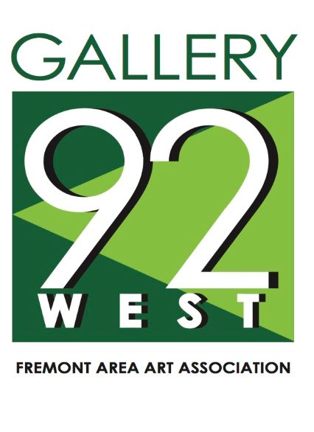
Exhibition Contract
This Exhibition Contract is made between ________________ (“Borrower”) and the Fremont Area Art Association (“FAAA”). The terms of the agreement are defined herein:
- Exhibition Title: The Exhibition Title is “Bridges: Sharing Our Past to Enrich the Future” (“the Exhibition”). This title will be used in all publications and publicity.
- Loan Period Dates: _________
The Exhibition will be open to the public __________________________________________
A reception will be held________________________________________________________
- Loan Contents: The contents of the loan will consist of artwork (mounted on 11”x14” metal panels), labels, promotional materials and other prepared materials ready for display. Borrower may choose to display entire Exhibition or a portion.
- Checklist Data: The FAAA will provide a checklist with the following data for each object in the Exhibition: Artist, Title, Date, Medium, Dimension, Insurance value plus any specific handling, shipping or installation instructions as may be necessary. This checklist will be provided by e-mail at least one week before the delivery of artwork.
- Fees: Borrower agrees to pay a Maximum Negotiable fee of $1000 plus shipping costs if applicable (including insurance) to host the Exhibition prior to the Exhibition being shipped. Fees are due prior to shipment and/or transport of the Exhibition.
- Transportation, Installation and Removal: FAAA will arrange shipment of the Exhibition. Borrower shall be responsible to inspect the contents and condition upon arrival, unload, install and pack the Exhibition. The pieces will not be removed from their original frames at any time. Borrower has the option to self-transport the Exhibition. If Borrower chooses self-transport, Borrower shall be responsible to inspect the contents and condition prior to departure and upon arrival.
- Insurance: The contents of the Exhibition will be insured by Borrower while in the possession of Borrower (including, but not limited to, during transport if Borrower chooses to self-transport). If the Exhibition is shipped via shipping service, Insurance will be included in the Fees. Borrow with provide a Certificate of Insurance to FAAA listing FAAA as an additional insured.
- Condition Reports: FAAA will provide condition reports to the Borrower with the shipment for delivery to the location of the Exhibition. If changes are noted in the condition of the content, FAAA will be notified within 48 hours. No contents will be removed or sold during the Exhibition. All contents will be returned in their original condition. Contents will be rewrapped and returned in their original shipping container(s).
- Security: The Borrower is responsible for the security, protection, and preservation of the Exhibition during the term it is in the Borrower’s possession. The Borrower will pay for any damaged or missing contents.
- Publicity: The Borrower will be responsible for advertising and promoting the Exhibition at the Borrower’s location. FAAA shall provide a press packet with approved promotional materials.
- Images, Copyright and Reproduction: The Borrower is given permission to reproduce any artworks included in the Exhibition for use on their website, announcements, exhibition brochures or catalogue, press releases, and any other promotional materials associated with the Exhibition for two months prior and during the loan period. Thereafter, Borrower may reproduce any Borrower generated images for future marketing. After conclusion the Exhibition, Borrower is prohibited from showing the exhibition in its entirety including, but not limited to photographic images, marketing materials, and virtual exhibitions. Borrower may not reproduce any content, in any medium for commercial purposes or sale. Copyrights apply to all photographic material.
- Display of the Exhibition:
- The Exhibition will be securely displayed in the space. The space shall be devoted exclusively to the Exhibition.
  - The Borrower can choose to show all or a portion of the Exhibition.
- The Borrower will not include content other than the Exhibition, except those consistent with promotion or credits attributed to the Borrower.
- The Exhibition space will be accessible to all, including those with disabilities.
- The Exhibition will be free and open to the public.
- The Borrower will maintain regularly-scheduled hours as agreed to by the parties to this agreement. Arrangements for operating hours, scheduling tours, and school field trips will be the responsibility of the Borrower. Outreach events are highly encouraged.
- The Borrower will provide staff and/or docents for tours.
- The Borrower will notify the FAAA of any public events encompassing the Exhibition during the Loan Period.
- The Exhibition will be hung and stored in secured areas.
- Changes to this Agreement: Any changes to this Agreement must be made in writing, signed by both parties.

__________________________________________ _______________________
Signature of Authorized Agent for the Borrower Date
Contact Information:

_________________________________________________________ ________________________________
Signature of Authorized Agent for FAAA Date
Contact Information:
Fremont Area Art Association
402-721-7779
gallery92west@92west.org

